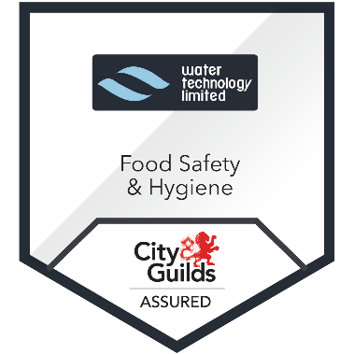
Food Safety & Hygiene

This course is aimed at those who are working in the food processing environment.
Topics include the importance of food hygiene with information on: food hazards; microbiological, physical and chemical allergens; standards of personal hygiene; best ways to follow good hygiene procedures and GMP standards; use of cleaning chemicals and equipment;, and, HACCP food safety management and controls.
Note: Please make Water Technology aware if any additional learning support is required.

Aims: Know how to operate hygienically in a food processing environment
Objectives:
- Identify the inputs affecting hygiene
- List 6 ways to promote good hygiene
- Describe good hand washing procedure
- Identify different bacteria affecting food processing
- Recognize the dangers relating to cleaning with chemicals
- Identify cleaning methods for COP
- State methods of evaluation for cleaning
- List 6 Allergens
- Identify contamination from CIP & COP (foreign body)

Duration
2 hours
Assessment: Multiple choice and short answer question paper. Q&A throughout session. 70% minimum is expected to achieve a pass rate.
Delivery: Classroom based
Contact:
Roselle Hoyne
Email: r.hoyne@wtlireland.com
Phone: +353 876093825

